**Department of Electrical Engineering and   
Computer Science**

**Faculty Member:** Dr. Arbab Latif  **Dated:** 21/02/2022

**Semester:** 4th **Section:** BEE 12C

**EE-222: Microprocessor Systems**

Lab 3: Functions, Branches and Delays

Group Members

|  |  |  |  |  |
| --- | --- | --- | --- | --- |
| **Name** | **Reg. No** | **Report**  **Marks / 10** | **Viva**  **Marks / 5** | **Total**  **Marks / 15** |
| Danial Ahmad | 331388 |  |  |  |
| Muhammad Umer | 345834 |  |  |  |
|  |  |  |  |  |
|  |  |  |  |  |

# Experiment

# Functions, Branches and Delays

## Objectives

1. Control GPIOs of ATmega16A
2. Implement branches in assembly language
3. Implement calculated delays
4. Break the code down to modular functions

## Equipment

Software

* *Atmel Studio*

Hardware

* ATmega16A microcontroller unit
* Universal Programmer
* Seven Segment Display
* Resistance 47Ω
* LEDs (may use from trainer kit)
* Switch or Button (may use from trainer kit)

## Introduction

 Atmel Studio IDE is a free development environment for programming Atmel MCUs, sourced by Microchip Technology Inc. It provides us with the means to simulate assembly language codes on specific Microcontrollers and provides an easy and intuitive way of producing .HEX files, which are what makes burning the code on the hardware possible.

In this specific lab, we familiarize ourselves with subroutines and branches in assembly language. We also observe the machine cycles that it takes to execute such subroutines and manually calculate the time delay. Lastly, we utilize the stack register within the SRAM portion of our data memory and the concept of a 16 – bit stack pointer to make a 7 word PALINDROME checker.

# Lab Tasks

## Task A

Turn an LED on or off by sensing a switch connected to a pin as schematic suggests.

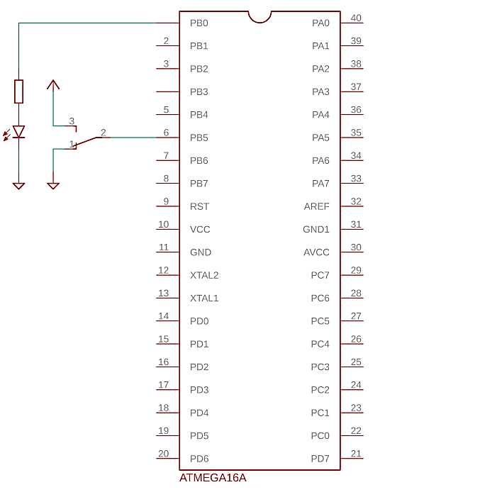

Logic low at pin should turn off the LED while logic high should immediately turn it on.

**;**

**; Lab3.asm**

**;**

**; Created: 24/02/2022 8:01:56 pm**

**; Author : Danial and Umer**

**;**

**; TASK A**

**.ORG 0x00**

**SBI DDRB, 0**

**CBI DDRB, 5**

**START: ; Passes on the value at Input at 5**

**; to the Output at 0**

**IN R16, PINB**

**BST R16, 5**

**BLD R17, 0**

**OUT PORTB, R17**

**NOP**

**RJMP START**



*Proteus Simulation*

## Task B

Implement a delay function for 500 milliseconds delay. Write an assembly program that utilizes this function to turn on an LED and wait 500 ms and then turn it off and wait 500 ms repeatedly in a loop.

Include your delay calculations in the report.

**;**

**; Lab3.asm**

**;**

**; Created: 24/02/2022 8:01:56 pm**

**; Author : Danial and Umer**

**;**

**; TASK B**

**.ORG 0X00**

**LDI R16, HIGH(RAMEND) ; Initialize Stack Pointer**

**OUT SPH, R16**

**LDI R16, LOW(RAMEND)**

**OUT SPL, R16**

**SBI DDRB, 0**

**START:**

**SBI PORTB, 0 ; TURNS LED ON**

**CALL DELAY ; 500 ms delay**

**CBI PORTB, 0 ; TURNS LED OFF**

**CALL DELAY ; 500 ms delay**

**RJMP START**

**.ORG 0X50**

**DELAY: ; Subroutine to add a delay of 500ms**

**LDI R16, 4 ; 1**

**DELAY_1:**

**LDI R17, 125 ; 1 * 4**

**DELAY_2:**

**LDI R18, 250 ; 1 * 125 * 4**

**DELAY_3:**

**DEC R18 ; (1 * 250) * 125 * 4**

**NOP ; (1 * 250) * 125 * 4**

**BRNE DELAY_3 ; (2 * 250 - 1) * 125 * 4**

**DEC R17 ;** **1 * 125 * 4**

**BRNE DELAY_2 ; (2 * 125 - 1) * 4**

**DEC R16 ;** **1 * 4**

**BRNE DELAY_1 ; (2 * 4) - 1**

**RET ; RETURNS back to Call 4**

## Delay Calculations

**1 clock cycle = 1 µs; 500 ms = 500000 µs**

* **Delay 3**

(4 * 250) – 1 = 999

* **Delay 2**

**Repeats Delay 3, 125 times**

999 * 125 = 124875

(4 * 125) – 1 = 499

124875 + 499 = 125374

* **Delay 1**

**Repeats Delay 2, 4 times**

125374 * 4 = 501496

(4 * 4) – 1 = 15

501496 + 15 = 501511 **->** + 5 **->** because of OVERHEAD and RET

**= 501516 µs**

Which is approximately what we desire



*Proteus Simulation*

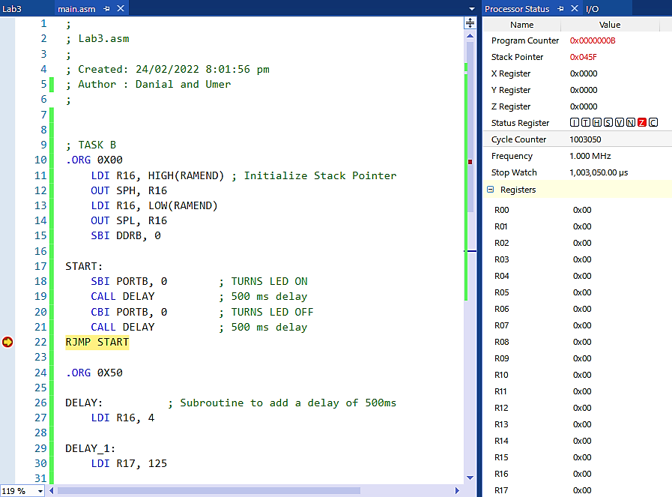

*Exemplar Output*



*Hardware Simulation*

## Task C

The following program stores seven characters in memory. Write a subroutine named CHECK **PALINDROME** that return 1 in R16 if this seven letter word is a palindrome else return 0 in R16. Utilize the property of AVR stack in your function.

Replace these seven characters with ”**ROTATOR**” and then with ”**JUMPOFF**” to check wether your function is general or not.

**;**

**; Lab3.asm**

**;**

**; Created: 24/02/2022 8:01:56 pm**

**; Author : Danial and Umer**

**;**

**; TASK C**

**.ORG 0x00**

**; Initializing stack pointer**

**LDI R31, HIGH(RAMEND) ; 0x04**

**OUT SPH, R31**

**LDI R31, LOW(RAMEND) ; 0x5F**

**OUT SPL, R31**

**; Storing the PALINDROME Word in 0x200 - 0x206 Address**

**LDI R16,'R'**

**PUSH R16**

**STS 0x200, R16**

**LDI R16,'A'**

**PUSH R16**

**STS 0x201, R16**

**LDI R16,'C'**

**PUSH R16**

**STS 0x202, R16**

**LDI R16,'E'**

**PUSH R16**

**STS 0x203, R16**

**LDI R16,'C'**

**PUSH R16**

**STS 0x204, R16**

**LDI R16,'A'**

**PUSH R16**

**STS 0x205, R16**

**LDI R16,'R'**

**PUSH R16**

**STS 0x206, R16**

**CALL CHECKPALINDROME ; Calling subrouting**

**HERE:**

**RJMP HERE**

**.ORG 0x50**

**; Your Code Here**

**CHECKPALINDROME:**

**POP R16 ; Increments Stack Pointer back up**

**POP R16 ; after CALL - RET decrements it by two**

**POP R16**

**LDS R17, 0x200**

**CP R16, R17**

**BRNE NE**

**POP R16**

**LDS R17, 0x201**

**CP R16, R17**

**BRNE NE**

**POP R16**

**LDS R17, 0x202**

**CP R16, R17**

**BRNE NE**

**POP R16**

**LDS R17, 0x203**

**CP R16, R17**

**BRNE NE**

**POP R16**

**LDS R17, 0x204**

**CP R16, R17**

**BRNE NE**

**POP R16**

**LDS R17, 0x205**

**CP R16, R17**

**BRNE NE**

**POP R16**

**LDS R17, 0x206**

**CP R16, R17**

**BRNE NE**

**EQ: ; For when PALINDROME = TRUE**

**; Altering the current address of SP to make RET to CALL feasible**

**LDI R31, 0x04**

**OUT SPH, R31**

**LDI R31, 0x56**

**OUT SPL, R31**

**LDI R16, 1**

**RET**

**NE: ; For when PALINDROME = False**

**; Altering the current address of SP to make RET to CALL feasible**

**LDI R31, 0x04**

**OUT SPH, R31**

**LDI R31, 0x56**

**OUT SPL, R31**

**LDI R16, 0**

**RET**

Which results in **R16** Register holding a value of **0x01** for the input word ‘**RACECAR’**.

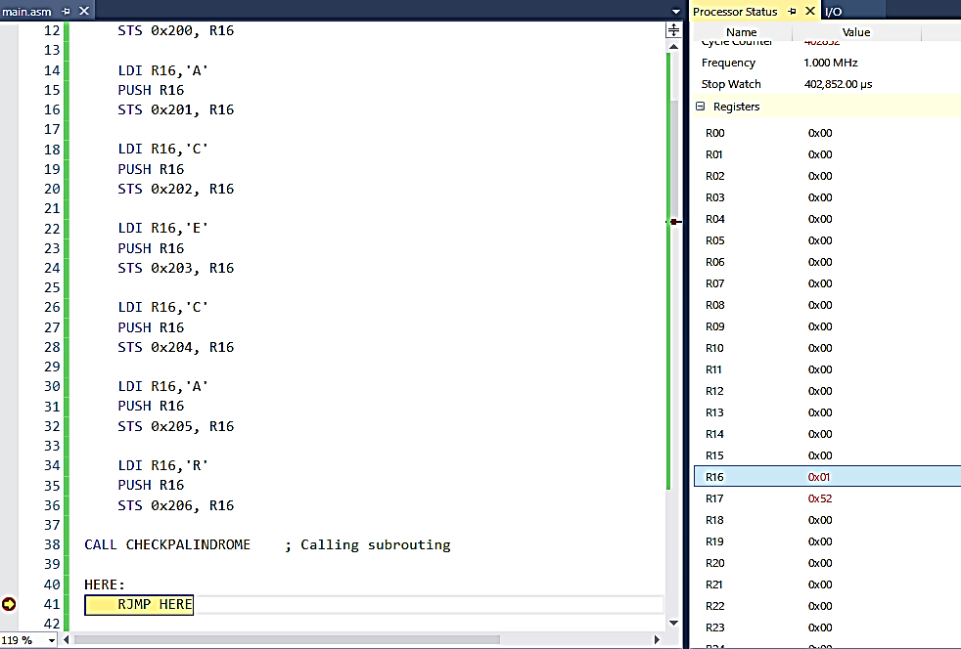

*Exemplar Output: RACECAR*

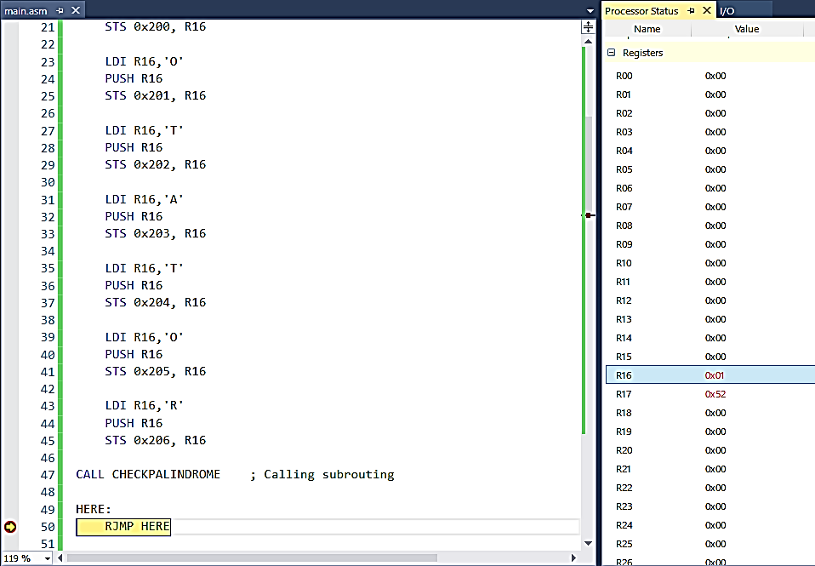

*Exemplar Output: ROTATOR*

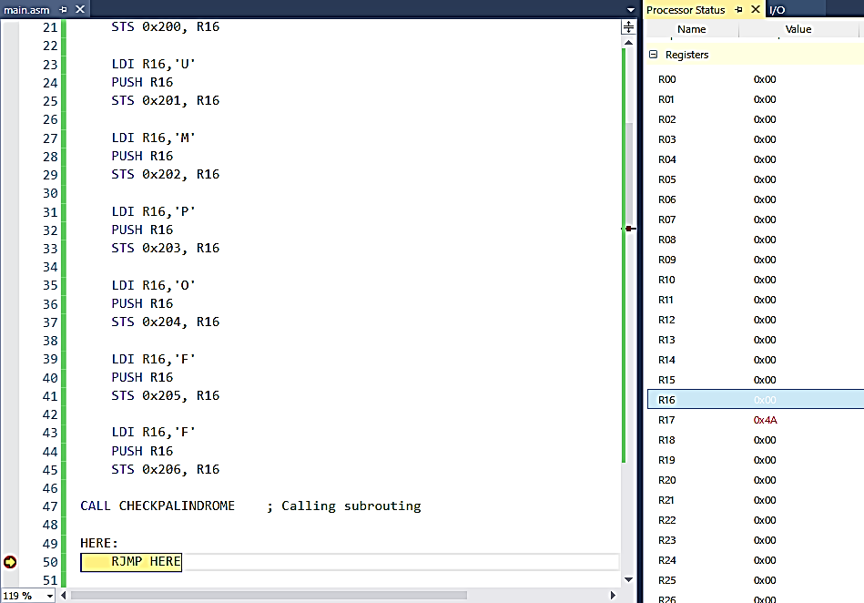

*Exemplar Output: JUMPOFF*

Hence, we can deduce that our **PALINDROME** checker is general for all 7 character words, as **R16** changed to **0x01** only for **RACECAR** and **ROTATOR**, and not for **JUMPOFF**.

## Conclusion

After the conduction of this lab, we have learnt how to utilize branching and loops to program an AVR to accomplish a multitude of tasks. We created a simple buffer switch to turn an LED ON/OFF through programming the I/O PORTS on our MCU and burning it on the ROM through a Universal Programmer. We also learned how to introduce time delays in our program through the use of nested loops and implemented a self – switching LED circuit. Lastly, utilizing our knowledge of SRAM and the Stack Pointer, we wrote a program that checks if a given 7 character word is a PALINDROME or not.